REPORT ON THE USEP

Containing the Contributions of Design and Principles Lead, Business Analyst, and Culture & Operations Lead

**GROUP MEMBERS:**

Nachula Nachamba – Cultural intelligence and Operations lead

Majata Hachimi – Business Analyst

Davies Manchishi – Design and Principles lead

# Design & principles lead: design process/artifacts, trends, principles vs application first.

**Introduction:**  
Software design in 2025 balances timeless principles with modern trends, aiming for systems that are scalable, sustainable, and adaptable. The Unified Student Experience Platform (USEP) embodies this by integrating academic, support, and community services into a single solution.  
  
**Design Process:**  
The design process bridges user needs and technical implementation through:  
1. Requirement’s analysis → understanding user and institutional needs.  
2. Architectural design → selecting structures and patterns.  
3. Detailed design → specifying components and interactions.  
4. Verification → ensuring alignment with requirements.  
  
**Artifacts:**- UML Use-Case Diagram: Shows interactions between actors (Student, Admin, AI Advisor, Financial System) and use cases (course registration, timetable, exam results, advising, events, forums, loan alerts). Demonstrates how services connect and interact.

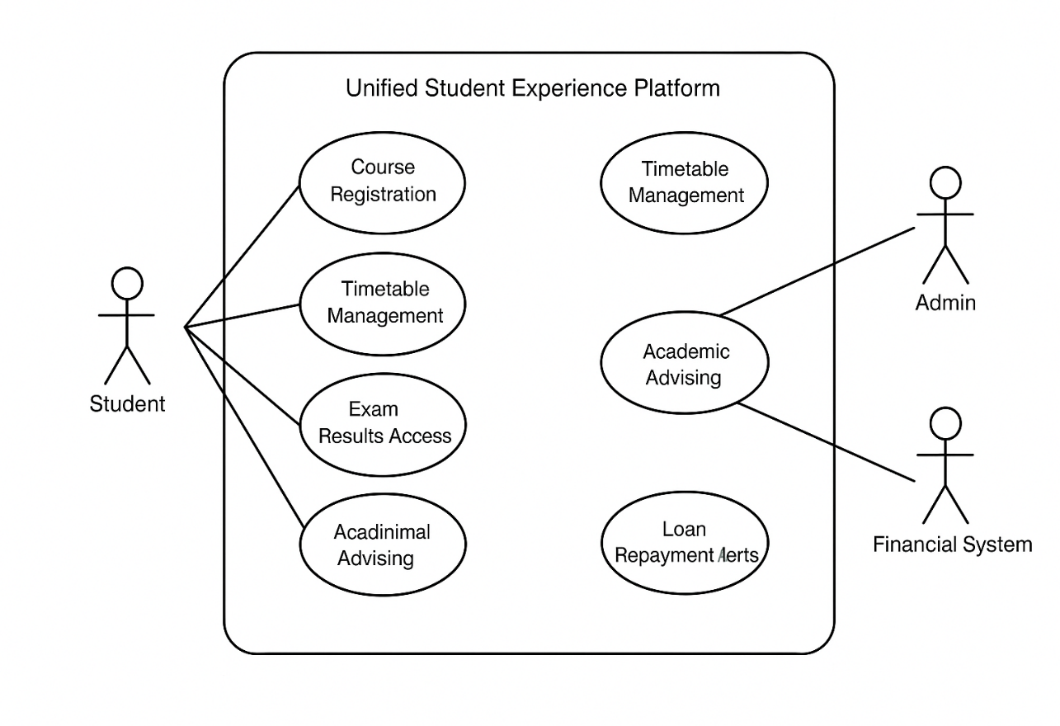

Architecture Decision Record (ADR): Captures critical architectural choices. For USEP, ADR 001 documents the adoption of microservices over monoliths for scalability, maintainability, and long-term adaptability.

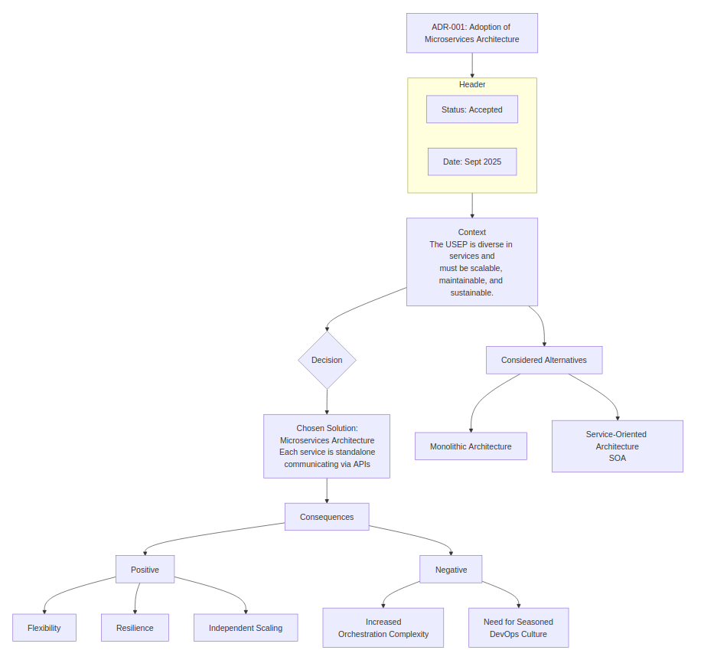**Principles vs Application-First:**  
- Principles-first ensures modularity, abstraction, scalability, and inclusivity.  
- Application-first speeds delivery but risks technical debt.  
- USEP balances both: principles guide design, agile practices enable speed.  
  
**Trends in 2025:**- AI-supported design tools.  
- Model-driven engineering (UML → prototype).  
- Cloud-based collaborative environments.  
- Domain-driven design (DDD).  
- Sustainable/green computing practices.  
  
**ADR Fit:**The ADR documents context, decision, rationale, and consequences (positive: scalability/flexibility; negative: DevOps complexity). It ensures transparent, principled design decisions.  
  
**Conclusion:**By combining UML diagrams (visual clarity) and ADRs (decision transparency), USEP’s design is future-proof, inclusive, and ethically aligned with long-term university goals. These artifacts ensure the platform’s design remains scalable, transparent, and trustworthy beyond 2025.

# Summary of Business Case and Outsourcing Analysis

### 1. Executive Overview

The institution plans to launch a **Unified Student Experience Platform by 2026** to address challenges in serving a growing, diverse student body with efficient, accessible, and timely services. The platform will also ease administrative workloads, reduce operating costs, and support better decision-making through improved data management.

Due to limited internal resources and expertise, the recommended approach is to **outsource development and deployment** of the platform to a specialized third-party developer.

### 2. Problem Statement

The institution faces:

* Increasing student numbers against limited staff and facilities.
* Diverse cultural and linguistic backgrounds, creating communication barriers.
* Administrative bottlenecks in managing student services and events.

Without intervention, these issues risk lowering student satisfaction and straining staff capacity.

### 3. Objectives

The platform aims to:

* Provide equitable access to services for all students, regardless of background.
* Support student learning and campus life through integrated **Learning Management Systems (LMS)**.
* Improve administrative efficiency via **Human Resource (HR) tools**.
* Reduce institutional costs by minimizing reliance on manual staff interventions.

### 4. Options Considered

**Option 1: In-house Development**

* Pros: Greater security, direct control, locally managed documentation.
* Cons: Skills gap, limited staff, longer delivery times.

**Option 2: Outsourced Development**

* Pros: Professional expertise, faster delivery, cost savings on staffing and materials.
* Cons: Risks of data breaches, less flexibility for future changes.

**Recommendation:** Outsource development to leverage external expertise and focus institutional resources on its core mission—supporting students.

### 5. Outsourcing Models

* **Onshore:** Easy communication and compliance but expensive.
* **Nearshore:** Cost-effective, culturally aligned, easier logistics, favorable legal frameworks.
* **Offshore:** Lowest costs and largest talent pool but high risks in quality control, security, and communication.

**Recommendation:** Nearshore outsourcing strikes the best balance between cost, accessibility, and compliance.

### 6. Scope & Deliverables

The platform will:

* Deliver a multilingual, accessible, and user-friendly system.
* Provide LMS features for students’ academic and social activities.
* Supply administrative tools for efficient operations.
* Exclude components outside student experience and staff efficiency.

### 7. Risks & Mitigation

* **Scalability:** Addressed through cloud hosting.
* **Security:** Use cybersecurity services.
* **Legal compliance:** Seek professional legal advice.
* **Delays:** Deploy features in phases.
* **Stakeholder dissatisfaction:** Engage students and staff in testing and feedback loops.

### 8. Conclusion

Implementing the Unified Student Experience Platform is critical to improving service delivery, lowering operational costs, and enhancing the overall student journey. Outsourcing—particularly via a nearshore model—offers the most practical path to success.

The institution requests **management approval** for outsourcing arrangements and budget allocation to initiate the project immediately.

**Culture & Ops Lead Contribution**

### Cultural Intelligence in Design Thinking

Cultural intelligence in design thinking ensures that the Unified Student Experience Platform (USEP) is inclusive and accessible for all students, regardless of their background. In practical terms, this means translating cultural awareness into concrete design requirements.

One key requirement is the development of a multilingual user interface. Since USEP will be accessed by students from different linguistic backgrounds, the interface should allow users to select their preferred language and seamlessly navigate the platform. This prevents language barriers from excluding certain students and ensures that information such as course materials, timetables, and financial aid notices is equally accessible.

Another requirement is the integration of accessibility features that support diverse learning needs. For example, the platform should provide screen reader compatibility, closed captions for video content, and adjustable font sizes for visually impaired students. In addition, it should comply with global accessibility standards such as WCAG (Web Content Accessibility Guidelines). By doing so, USEP guarantees that students with disabilities have the same access to resources and opportunities as their peers.

### AI Awareness: Opportunity and Ethical Concern

Artificial intelligence offers powerful opportunities for enhancing the student experience on USEP. One such opportunity is an advising chatbot that provides real-time academic and administrative support. Instead of waiting to meet an advisor, students can ask the chatbot questions about course requirements, assignment deadlines, or financial aid procedures. This improves accessibility and reduces delays, particularly for students studying across different time zones.

However, an ethical concern arises when considering how the chatbot generates its guidance. If trained on biased data, the system may inadvertently disadvantage certain groups of students. For example, it might suggest limited career pathways to women or underrepresent opportunities for international students. This issue goes beyond simple “error” and reflects structural bias within data itself. To address this, the chatbot must be designed with transparency, fairness, and regular audits to ensure recommendations are balanced and inclusive.

### DevOps and DevSecOps Integration

The operational success of USEP depends on embedding DevOps and DevSecOps practices early in the design process. DevOps enables continuous integration (CI) and continuous deployment (CD), which means that new features, such as timetable updates or financial aid modules, can be tested and deployed quickly. DevSecOps extends this by integrating security checks into the pipeline, ensuring that vulnerabilities are identified and resolved before deployment.

The basic CI/CD pipeline for USEP can be illustrated as follows:

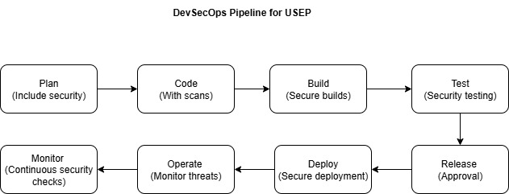

In this pipeline, developers first write and commit code, which is automatically built and tested. Security scans are then applied to identify risks before deployment. Once the feature is deployed, the system is monitored in real time, allowing for continuous improvement. This pipeline supports both agility and trustworthiness, ensuring that USEP remains scalable while protecting sensitive student data.

**CONCLUSION**

By translating cultural intelligence into practical design requirements, integrating DevOps and DevSecOps practices into a secure CI/CD pipeline, and balancing the benefits of AI with awareness of ethical risks, USEP can be built as a platform that is inclusive, scalable, and trustworthy. This approach ensures that the system not only supports academic administration but also embodies values of diversity, accountability, and responsible innovation.